Gas Properties: Understanding Gas Model
Purpose
To describe the molecular model of gas pressure by simulated lab
Hypothesis
Null hypothesis; increase in pressure does not lead to an increase in the speed of gas particles in the closed container system
Alternative hypothesis; increase in pressure leads to increase in the speed of gas particles in the closed container system.
Procedure of The Experiment.
To test for ideal gas properties using the molecular model on the simulated lab, width of the container was first set to 10nm. Wall collision and Sample period was also done, this was followed by setting temperatures in ℃ which was changed at interval to determine its effect on the particles movement. Both heavy and light particles were quantified and the loaded into the pump then released into the container. the wall collision rate was recorded after every period of 10ps. The experiment was then repeated with individual light and heavy separately and their properties recorded below.
The number of particles for heavy and light was kept constant at 30 (heavy 15 and light 15)

Results
Temperature (℃) | 20 | 40 | 60 | 80 | 100
Wall collisions at pressure of 3 atm | 34 | 37 | 42 | 58 | 73

Temperature | Heavy | Light
20 | 15 | 21
40 | 22 | 33
60 | 34 | 43
80 | 40 | 102

Analysis and Conclusions
From the above recorded results, the effect of temperature on the collision number of the gas particles on the wall of the container were determined to be directly proportional. When the temperature is increased, the particles gains kinetic energy which enables them to move more faster hence hitting the walls of the vessel more frequently.
Light gas particles have high collision rate due to their small size which enables them to migrate faster in direct relation to the temperature. The heavy particles have lower collision rate due to their large sizes compared to light particles.

PV = nRT
The size of the heavy particles
3atm * 10nm =n * 0.082 *333K
N = 1.1 mols
Number of moles at 273K is 1.1

it is evidenced from the experiment that an increase in temperature increases the kinetic energy of the gas particles therefore temperature and collision frequency of the gas particles are directly proportional. Size of the particles also affects the collision speed of the particles. Heavy particles move at lower speed than lighter particles
lab questions
- A molecule travels many times as fast as a car

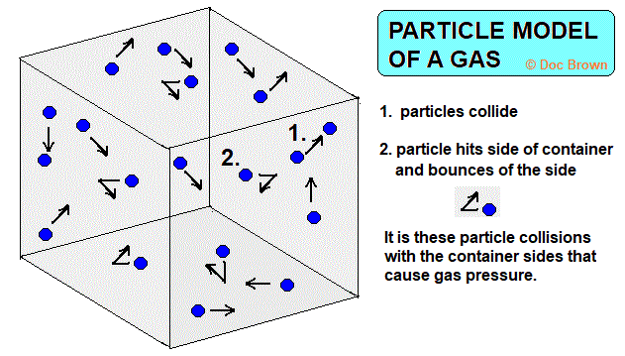

- Gases are distinguished from solids by the distances between the particles which forms the matter. Gases have their particles far apart as compared to both liquid and gases
- Heavy particles require high temperatures to be activated. therefore, when the image temperature is increased, the the particles will appear to be more compacted and random.
- Smaller gas particles are mostly are lighter hence they are normally used in sky scraping objects e.g hot air balloon. Helium is a typical of a gas used in hot air balloon.
- Similarities
Gases, liquids and solids are all made up of atoms, molecules, and ions.
These particles however behave differently in the three phases as illustrated below.
In gases, the particles can move past one another with a lot of space between one another. In liquid phase particles have limited space between them and tend to be a little bit fixed while in solid stat, particles are rigid and locked into place, they have little free space between them.

